**MINI PROJECT SYNOPSIS**

ON

**BRAIN.MRI**

**A CNN based approach to detecting Alzheimer’s Disease using Brain MRI scans**

(CSE VI Semester Mini Project)

2021-2022



|  |  |
| --- | --- |
| Submitted to: | Submitted by: |
| Mr. Avnish Panwar | Aytijha Chakraborty |
| (CC-CSE-K-VI-Sem) | Roll. No.: 1914009 |
|  | CSE-K-VI-Sem |

**DEPARTMENT OF COMPUTER SCIENCE AND ENGINEERING**

**GRAPHIC ERA HILL UNVERSITY, DEHRADUN**

1. ABOUT PROJECT

This project aims at detecting Alzheimer's Disease using Brain MRI scans and classifying its stage, using Deep Learning. This is done using a variety of tools, libraries and modules. This project was written and compiled on Visual Studio using iPython Notebook on Windows 11 OS.

1. PRE-REQUISITES OF PROJECT

Tested support for OS: Windows 11, Mac 10.15.7, Ubuntu 20.04 LTS

Softwares/Frameworks Used:

* Python 3.10
* Visual Studio Code
* HTML 5
* CSS 3
* Bootstrap 5.2
* JavaScript ES2015
* iPython 7.12.0
* Flask 2.1.2 (Python)
* Werkzeug 2.1.2 (Python)
* NumPy 1.22.0 (Python)
* TensorFlow 2.8.0 (Python)
* Matplotlib 3.5.1 (Python)
* OpenCV 4.5.5 (Python)
* Imbalanced-learn 0.9.1 (Python)
* Scikit-Learn 1.1.1 (Python)
* Seaborn 0.11.2 (Python)

Softwares/Frameworks Required To Run:

* iPython 7.12.0
* Flask 2.1.2 (Python)
* Werkzeug 2.1.2 (Python)
* NumPy 1.22.0 (Python)
* TensorFlow 2.8.0 (Python)

1. MODULES OF PROJECT

The project comprises of 3 modules:

* 1. Data Acquiring and Preprocessing:
     1. Data acquired from Kaggle user [Sarvesh Dubey](https://www.kaggle.com/tourist55), who provided a dataset consisting of 6000+ MRI images belonging to four classes of images both in training as well as a testing set:
        1. Mild Demented,
        2. Moderate Demented,
        3. Non-Demented,
        4. Very Mild Demented.
     2. Used [ImageDataGenerator](https://www.tensorflow.org/api_docs/python/tf/keras/preprocessing/image/ImageDataGenerator) (Tensorflow) to augment the images from the Training Dataset and form new training samples in real-time while the model is still training.
     3. Performed over-sampling of the data using [SMOTE](https://imbalanced-learn.org/stable/references/generated/imblearn.over_sampling.SMOTE.html) to eliminate the class imbalance in the Training dataset.
  2. Model Training and Evaluation:
     1. Model architecture:

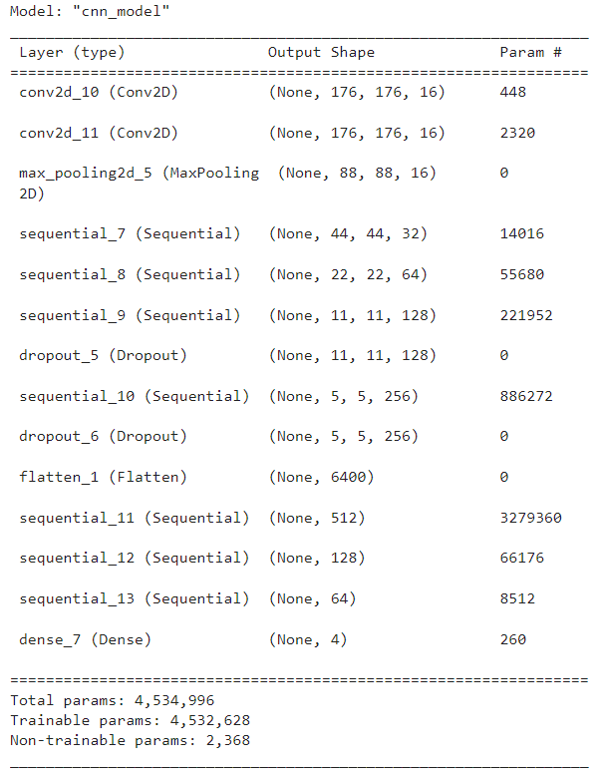

* + 1. Model trained for 100 epochs, with a validation split of 20%, resulting in:

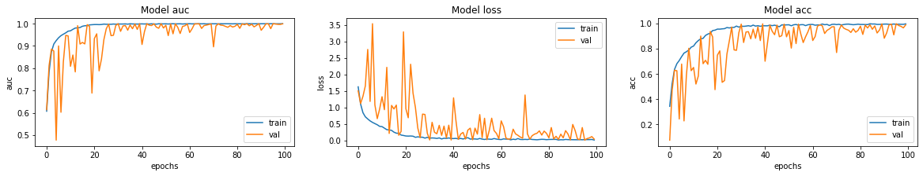

* + 1. When tested on previously unseen data (~1500 images), the results were: loss: 1.9561, acc: 0.6435, auc: 0.8288
    2. It was observed from the confusion matrix that the model was a little confused with Very Mildly Demented and Non-demented samples.

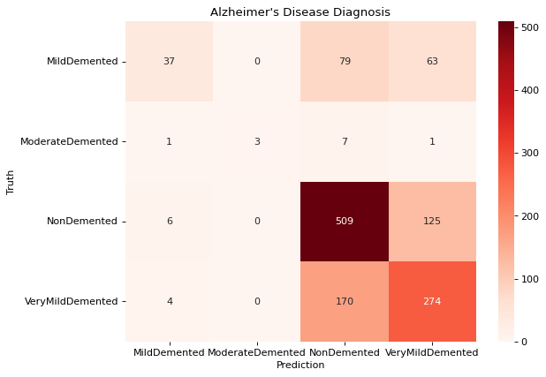

* 1. Flask App:
     1. An HTML page is rendered through Flask to retrieve User-MRI file through a form.
     2. The HTML template is adorned using CSS, Bootstrap, Google Fonts, icons from [Icon8](https://icons8.com/), background video from [Pexels](https://www.pexels.com/), and JavaScript.
     3. The MRI image file is converted to an image array of suitable dimensions for the model to work upon.
     4. The model classifies a type of Dementia (from the previously mentioned 4 classes) and the output is printed both on the webpage and the terminal.
     5. The image file is also saved to the device for future uses.

1. DATA FLOW DIAGRAM

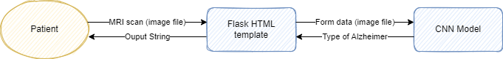

1. OUTPUT GIF



1. REFERENCES

* <https://aytijha.github.io/BRAIN.MRI/>
* <https://www.tensorflow.org/api_docs/python/tf/keras/preprocessing/image/ImageDataGenerator>
* <https://imbalanced-learn.org/stable/references/generated/imblearn.over_sampling.SMOTE.html>